CHAPTER FOUR
DATA ANALYSIS AND INTERPRETATION
  - Preamble
In this chapter, we delve into the heart of the research by carefully analyzing the collected data and presenting the findings in a clear and coherent manner. The goal of this chapter is to transform raw data into meaningful insights that address the research questions and objectives outlined earlier in the study. The presentation of results was derived from responses received from the respondents. Descriptive statistics such as percentages, frequencies, mean and standard deviation were used to summarize the demographic data and responses of the questionnaire. A one-tailed test was employed to assess the directional nature of the hypotheses.

  - Descriptive analysis of the socio-demographic data of the respondents
The socio-demographic characteristics of respondents are crucial for understanding the content of the research and to also provide insights into the diversity and representativeness of the sample.
S/N | Variables |  | (N) | (%)
 | Gender  Marital status | Male | 69 | 51.9%
 | Gender  Marital status | Female | 64 | 48.1%
 | Gender  Marital status | Total | 133 | 100%
 | Gender  Marital status | Single | 84 | 63.2%
 | Gender  Marital status | Married | 49 | 36.8%
 | Gender  Marital status | Total | 133 | 100%
 | Age grade | 0 - 20 | 9 | 6.8%
 | Age grade | 21 – 30 | 32 | 24.1%
 | Age grade | 31 – 40 | 46 | 34.6%
 | Age grade | 41 and above | 46 | 34.6%
 | Age grade | Total | 133 | 100%
 | Educational qualification | FSLC | 5 | 3.8%
 | Educational qualification | SSCE/WAEC | 12 | 9%
 | Educational qualification | NCE/OND | 13 | 9.8%
 | Educational qualification | HND/BSc | 60 | 45.1%
 | Educational qualification | Master’s Degree | 37 | 27.8%
 | Educational qualification | PhD | 6 | 4.5%
 | Educational qualification | Total | 133 | 100%

INTERPRETATION
The socio demographic details of the respondents displayed above shows the percentages and frequencies of various categories associated with the respondents. The gender distribution shows a significant advantage towards the male gender with 69 respondents as it accounts for 51.9% of the sample population compared to 64 females which represents 48.1%.

In terms of marital status, the majority of respondents are single with 69 respondents accounting for 51.9% of the total. Respondents who fall within the married category are 64 with 48.1% of the total.

Regarding the Age group, the highest group of respondents falls within two group (31-40 and 41 and above), comprising 46 participants respectively which accounts for 34.6% of the total. The next significant group is 21-30 with 32 respondents accounting for 24.1% of the total, followed by age group 0-20 with 9 respondents (6.8%) as depicted above.

Also, in the educational qualification category, respondents in HND/BSC category are the highest with 60 respondents occupying 45.1% of the total, the next is masters’ degree with 37 respondents occupying 27.8% of the total followed by NCE/OND with 13 respondents occupying 9.8% of the total, SSCE/WAEC with 12 respondents (9%), PhD with 6 respondents (4.5%) and lastly FSLC with 5 respondents occupying 3.8% of the total.

The detailed breakdown of the respondents’ demographic characteristics provides a comprehensive understanding of the diversity within the sample population and also ensures that the findings reflect a broad spectrum of perspectives.

  - Descriptive Analysis of Respondents to Research Questions

Research Question 1: REGULAR SALARY AND RETENTION
S/N | ITEMS | SA | A | D | SD | Mean | S. D
1 | My salary is paid regularly without delay | 39  (29.3) | 52  (39.1) | 32  (24.1) | 10  (7.5) | 2.90 | 0.91
2 | I am satisfied with the consistency of salary payment | 45  (33.8) | 54  (40.6) | 17  (12.8) | 17  (12.8) | 2.95 | 0.99
3 | Regular salary motivates me to stay with my current employer. | 32  (24.1) | 68  (51.1) | 22  (16.5) | 11  (8.3) | 2.91 | 0.86
4 | Late salary payment makes me consider changing jobs. | 32  (24.1) | 74  (55.6) | 10  (7.5) | 17  (12.8) | 2.91 | 0.91
5 | Prompt salary payment increases employee loyalty | 26  (19.5) | 73  (54.9) | 28  (7.5) | 6  (4.5) | 2.89 | 0.76
6 | I feel secure in my job because I receive regular salary | 24  (18) | 56  (42.1) | 27.1  (27.1) | 17  (12.8) | 2.65 | 0.92

Interpretation of table data:
For question 1, “My salary is paid regularly without delay” 29.3% of the respondents strongly agree, 39.1% agree, 24.1% disagree while 7.5% strongly disagreed. For research question 2, “I am satisfied with the consistency of salary payment” 33.8% of the respondents strongly agreed, 40.6% agree, 12.8% disagree while 12.8% strongly disagreed. For research question 3: “Regular salary motivates me to stay with my current employer”, 24.1% strongly agree, 51.1% agreed, 16.5% disagreed while 8.3% strongly disagreed. For research question 4, “Late salary payment makes me consider changing jobs”, 24.1% of the respondents strongly agree, 51.1% agree, 16.5% disagree while 8.3% strongly disagreed. For research question 5: “Prompt salary payment increases employee loyalty”. 19.5% strongly agree, 54.9% agreed, 7.5% disagreed while 4.5% strongly disagreed. For research question 6, “I feel secure in my job because I receive regular salary”, 18% of the respondents strongly agree, 42.1% agree, 27.1% disagree while 12.8% strongly disagreed.

Research Question 2: BONUSES AND EMPLOYEE SATISFACTION

S/N | ITEMS | SA | A | D | SD | Mean | S. D
1 | I receive bonuses for good performance. | 43  (32.3) | 63  (47.4) | 18  (13.5) | 9  (6.8) | 3.05 | 0.86
2 | Bonuses motivate me to work harder | 49  (36.8) | 67  (50.4) | 2  (1.5) | 15  (11.3) | 3.13 | 0.91
3 | I feel appreciated when bonuses are given. | 23  (17.3) | 63  (47.4) | 29  (21.8) | 18  (13.5) | 2.68 | 0.92
4 | Bonus payment is consistent in this organization. | 22  (16.5) | 64  (48.1) | 36  (27.1) | 11  (8.3) | 2.73 | 0.84
5 | Lack of bonuses affects my job satisfaction | 28  (21.1) | 71  (53.4) | 21  (15.8) | 13  (9.8) | 2.25 | 0.60
6 | I am more satisfied when bonuses are tied to performance. | 43  (32.3) | 74  (55.6) | 10  (7.5) | 6  (4.5) | 2.65 | 0.92

Interpretation of table data:
For question 1: “I receive bonuses for good performance”. 32.3% of the respondents strongly agree, 47.4% agree, 13.5% disagree while 6.8% strongly disagreed. For research question 2, “Bonuses motivate me to work harder”. 36.8% of the respondents strongly agreed, 50.4% agree, 1.5% disagree while 11.3% strongly disagreed. For research question 3: “I feel appreciated when bonuses are given”. 17.3% strongly agree, 47.4% agreed, 21.8% disagreed while 13.5% strongly disagreed. For research question 4, “Bonus payment is consistent in this organization.”, 16.5% of the respondents strongly agree, 48.1% agree, 27.1% disagree while 8.3% strongly disagreed. For research question 5: “Lack of bonuses affects my job satisfaction”. 21.1% strongly agree, 53.4% agreed, 15.8% disagreed while 9.8% strongly disagreed. For research question 6, “I am more satisfied when bonuses are tied to performance”, 32.3% of the respondents strongly agree, 55.6% agree, 7.5% disagree while 4.5% strongly disagreed.

Research Question 3: PROMOTION AND JOB COMMITTMENT
S/N | ITEMS | SA | A | D | SD | Mean | S. D
1 | I feel motivated when my efforts are recognized. | 41  (30.8) | 64  (48.1) | 17  (12.8) | 11  (8.3) | 3.02 | 0.88
2 | I am more committed when promotion is based on merit. | 22  (16.5) | 76  (57.1) | 24  (18) | 11  (8.3) | 2.82 | 0.81
3 | Recognition improves my loyalty to this organization. | 20  (3.8) | 89  (66.9) | 19  (14.3) | 5  (3.8) | 2.93 | 0.67
4 | I am likely to stay longer when my work is appreciated. | 31  (23.3) | 69  (51.9) | 27  (20.3) | 6  (4.5) | 2.94 | 0.79
5 | I put in extra effort when I am publicly recognized | 32  (24.1) | 77  (57.9) | 19  (14.3) | 5  (3.8) | 3.02 | 0.73
6 | Promotion makes me feel valued as an employee. | 17  (12.8) | 71  (53.4) | 31  (23.3) | 14  (10.5) | 2.68 | 0.83

Interpretation of table data:
For question 1 “I feel motivated when my efforts are recognized” 30.8% of the respondents strongly agree, 48.1% agree, 12.8% disagree while 8.3% strongly disagreed. For research question 2, “I am more committed when promotion is based on merit”. 16.5% of the respondents strongly agreed, 57.1% agree, 18% disagree while 8.3% strongly disagreed. For research question 3: “Recognition improves my loyalty to this organization” 3.8% strongly agree, 66.9% agreed, 14.3% disagreed while 3.8% strongly disagreed. For research question 4, “I am likely to stay longer when my work is appreciated” 23.3% of the respondents strongly agree, 51.9% agree, 20.3% disagree while 4.5% strongly disagreed. For research question 5: “I put in extra effort when I’m publicly recognized” 24.1% strongly agree, 57.9% agreed, 14.3% disagreed while 3.8% strongly disagreed. For research question 6, “Promotion makes me feel valued as an employee”, 12.8% of the respondents strongly agree, 53.4% agree, 23.3% disagree while 10.5% strongly disagreed.

Research Question 4: EMPLOYEE TRAINING AND WORK-QUALITY

S/N | ITEMS | SA | A | D | SD | Mean | S. D
1 | I have received adequate training to perform my job well. | 27  (20.3) | 72  (54.1) | 21  (15.8) | 13  (9.8) | 2.85 | 0.86
2 | Training has improved the quality of my work. | 25  (18.8) | 74  (55.6) | 22  (16.5) | 12  (9) | 2.84 | 0.83
3 | Ongoing training helps me stay updated with job demands. | 19  (14.3) | 79  (59.4) | 23  (17.3) | 12  (9) | 2.79 | 0.80
4 | Lack of training affects my job performance negatively. | 21  (15.8) | 79  (59.4) | 20  (15) | 13  (9.8) | 2.81 | 0.82
5 | The training I received is relevant to my job tasks. | 35  (26.3) | 71  (53.4) | 24  (18) | 3  (2.3) | 3.04 | 0.73
6 | Employee training contributes to better service delivery. | 22  (16.5) | 70  (52.6) | 25  (18.8) | 16  (12) | 2.74 | 0.88

Interpretation of table data:
For question 1 “I have received adequate training to perform my job well” 20.3% of the respondents strongly agree, 54.1% agree, 15.8% disagree while 9.8% strongly disagreed. For research question 2, “Training has improved the quality of my work.”. 18.5% of the respondents strongly agreed, 55.6% agree, 16.5% disagree while 9% strongly disagreed. For research question 3: “Ongoing training helps me stay updated with job demands.” 14.3% strongly agree, 59.4% agreed, 17.3% disagreed while 9% strongly disagreed. For research question 4, “Lack of training affects my job performance negatively” 15.8% of the respondents strongly agree, 59.4% agree, 15% disagree while 9.8% strongly disagreed. For research question 5: “The training I received is relevant to my job tasks” 26.3% strongly agree, 53.4% agreed, 18% disagreed while 2.3% strongly disagreed. For research question 6, “Employee training contributes to better service delivery”, 16.5% of the respondents strongly agree, 52.6% agree, 18.8% disagree while 12% strongly disagreed.

  - Test of Hypotheses
In this section, the proposed null hypotheses were put to test. The p value must be less than the standard significant level of 0.05 for the test to result in a rejection of the null hypotheses.

    - Hypothesis One
H_{o}: Regular salary has no significant effect on employee retention
H_{i}: Regular salary has significant effect on employee retention
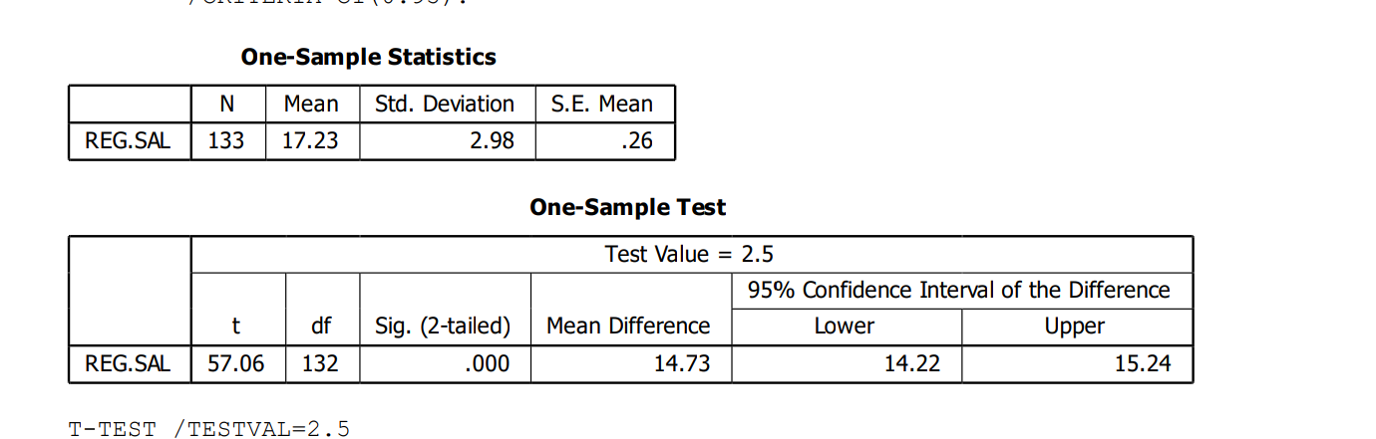Interpretation
The purpose of this one-sample t-test was to determine whether the mean of the sample (133 observations) significantly differs from a hypothesized population mean of 2.5. The sample yielded a mean of 17.23, with a standard deviation of 2.98 and a standard error of 0.26. The test produced a t-statistic of 57.06 with 132 degrees of freedom, and a two-tailed p-value of .000. This p-value is far below the conventional significance threshold of 0.05, indicating that the observed difference between the sample mean and the hypothesized value is statistically significant and not likely due to random chance. The mean difference between the sample and the test value is 14.73, and the 95% confidence interval for this difference ranges from 14.22 to 15.24. Since this interval does not include the test value of 2.5, it further supports the conclusion that the sample mean is significantly different from the hypothesized population mean.

Decision
Given the extremely high t-value, the negligible p-value, and the confidence interval that excludes the test value, we can confidently reject the null hypothesis. This means that there is strong evidence to conclude that the true population mean is not equal to 2.5 and is substantially higher.

    - Hypothesis Two
H_{o}: Bonus has no significant effect on employee satisfaction
H_{i}: Bonus has no significant effect on employee satisfaction

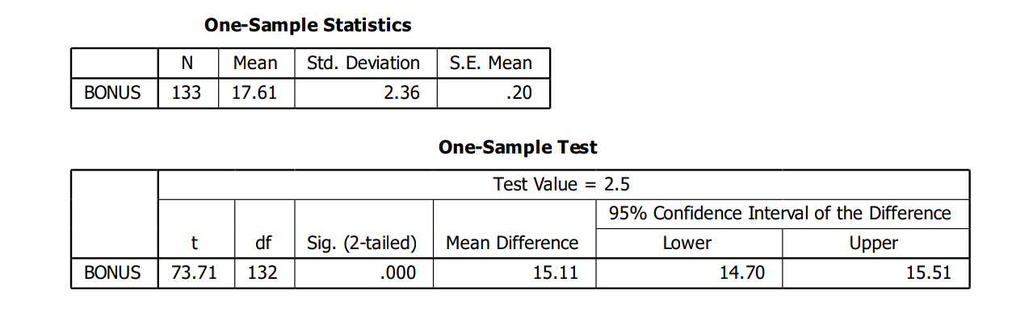
Interpretation
This table presents the results of a one-sample t-test, which compares the sample mean to a hypothesized population mean (test value) of 2.5. The p-value is less than 0.001, meaning the result is statistically significant. The sample mean is 17.61, which is much higher than the test value. The t-statistic of 73.71 is extremely large, indicating a strong deviation from the hypothesized mean. The p-value of .000 (i.e., < 0.001) shows that this difference is statistically significant. 95% Confidence Interval 14.70 to 15.51, means that there is 95% confidence that the true mean difference lies within this range The confidence interval does not include the test value of 2.5, reinforcing the conclusion that the sample mean is significantly different.

Decision
You should reject the null hypothesis. The evidence strongly supports the alternative hypothesis as the true population mean bonus is significantly greater than 2.5. This result is not only statistically significant but also practically meaningful, given the large mean difference of 15.11.

    - Hypothesis Three
H_{o}: Employee recognition does not significantly influence job commitment
H_{i}: Employee recognition significantly influences job commitment 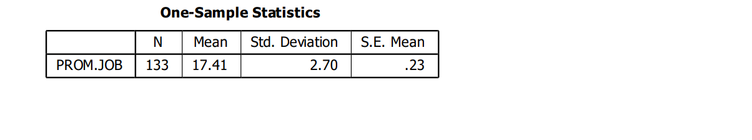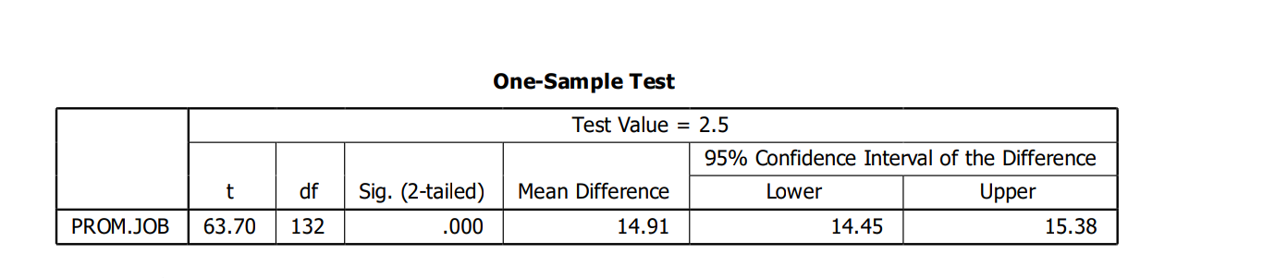

Interpretation
This section presents the results of a one-sample t-test, which compares the sample mean to a hypothesized population mean (test value) of 2.5. The t-statistic 63.70, a very large value, indicating a strong deviation from the test value. The p-value is less than 0.001, meaning the result is statistically significant. Mean difference of 14.91 means the sample mean exceeds the test value by 14.91 units. 95% Confidence Interval 14.45 to 15.38, means that there is 95% confidence that the true mean difference lies within this range. The interval does not include the test value, reinforcing the significance of the result. The sample mean is 17.41, which is substantially higher than the test value.

Decision
You should reject the null hypothesis. The statistical evidence strongly supports the alternative hypothesis. The true population mean is significantly greater than 2.5. This result is both statistically significant and practically meaningful, given the large mean difference of 14.91.

    - Hypothesis Four
H_{o}: Employee training does not have significant effect on the quality of work
H_{i}: Employee training has significant effect on the quality of work 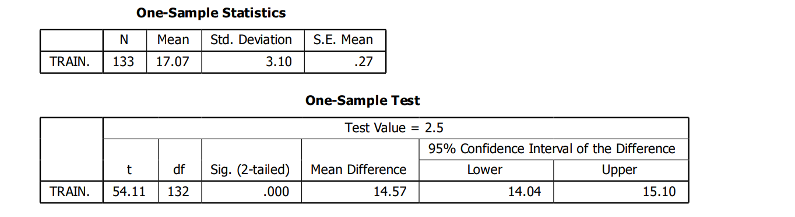
Interpretation
This section presents the results of a one-sample t-test, which compares the sample mean to a hypothesized population mean (test value) of 2.5. The t-statistic of 54.11 is extremely high, indicating a strong and statistically significant difference. The p-value is less than 0.001, meaning the result is statistically significant and it also indicates that the difference is not due to random chance. Mean Difference of 14.57 means the sample mean exceeds the test value by 14.57 units. 95% Confidence Interval 14.04 to 15.10 means that there is 95% confidence that the true mean difference lies within this range. The interval does not include the test value, reinforcing the significance of the result. The sample mean is 17.07, which is substantially higher than the test value.

Decision
You should reject the null hypothesis. The statistical evidence strongly supports the alternative hypothesis: the true population mean is significantly greater than 2.5. This result is both statistically significant and practically meaningful, given the large mean difference of 14.57.

